Collect Data for Customer AzureAD Setup

For step 11 in the Customer Manual
When setting up the customer AzureAD, they will need to add our congito APIs as acceptable destinations when returning authentication responses (tokens) after successfully authenticating or signing out users.

These URIs are:
- https://{customer}-users.auth.eu-central-1.amazoncognito.com/saml2/idpresponse
- https://{customer}-users.auth.eu-central-1.amazoncognito.com/oauth2/idpresponse

The {customer} value should be filled in using the “Domain name” configured in AWS Cognito:
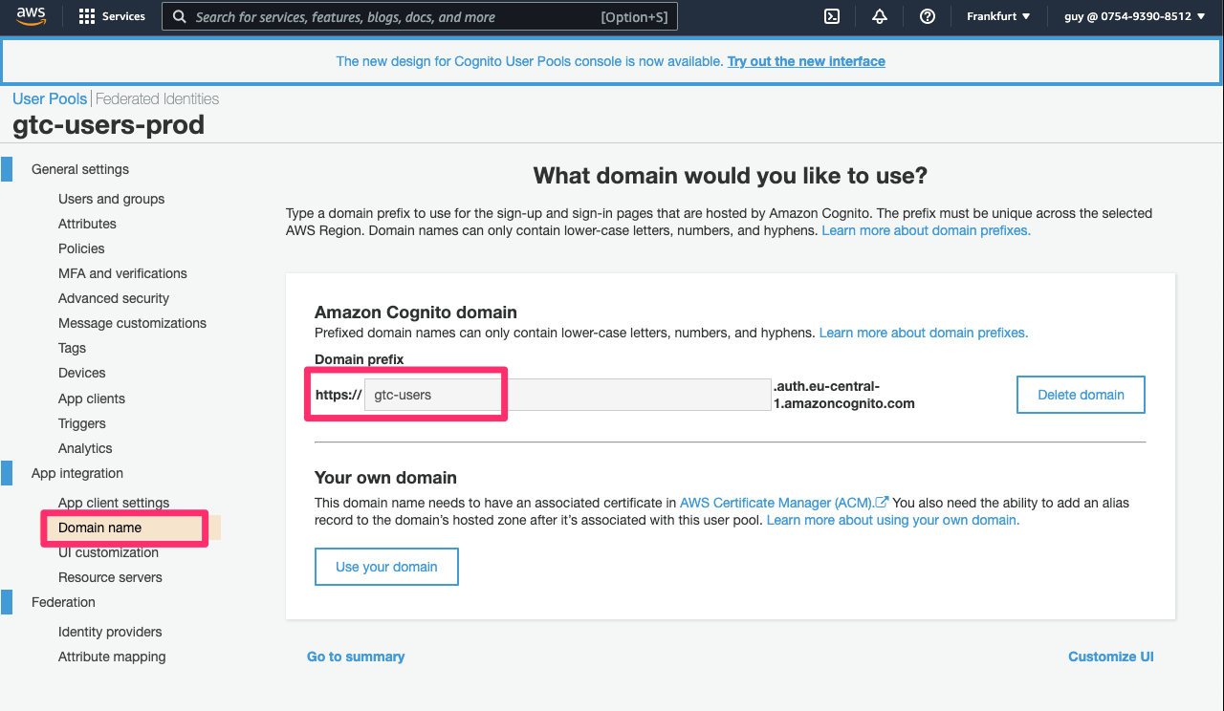

For step 16 in the Customer Manual
The tenant URI has the following structure: "urn:amazon:cognito:sp:<tenant_uri_value>".
The value we need to complete this template is the Pool ID in Cognito, which can be found in the “General Settings” page of the customer’s pool in AWS Cognito.

For example:
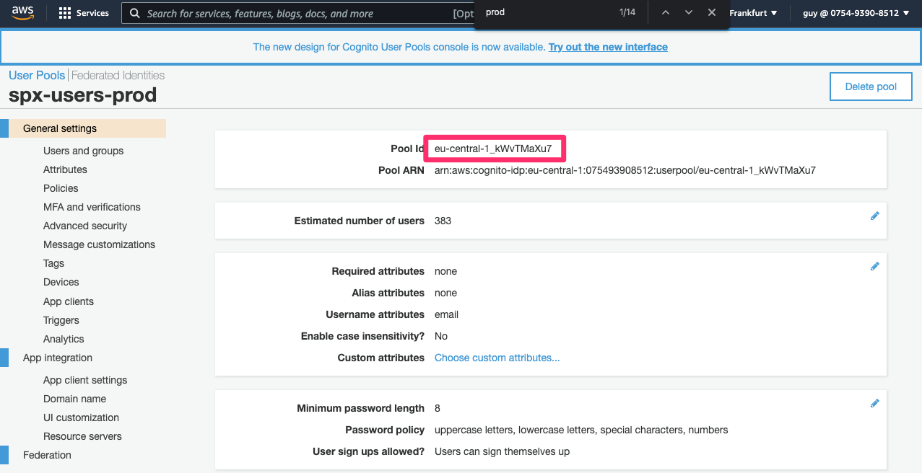

Here the values will be:
tenant_uri_value = eu-central-1_v4SQ4m1KD
tenant_uri = arn:amazon:cognito:sp:eu-central-1_v4SQ4m1KD

Setup the AWS Cognito side
- Browse to the relevant User Pool in AWS Cognito console and click “General settings”
  - Copy and save “Pool Id” - you will use it to complete the Azure side of setup
- Go to “App Integration” in the left menu
  - Copy “Domain” - you will use it to complete the Azure side of setup
- Go to “Identity providers” in the left menu, then click on “OpenID Connect”
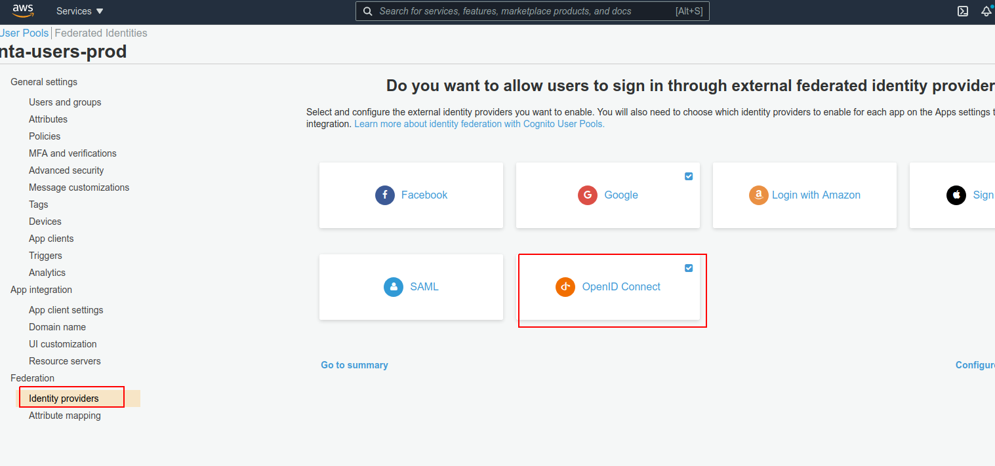
- Enter the following details:
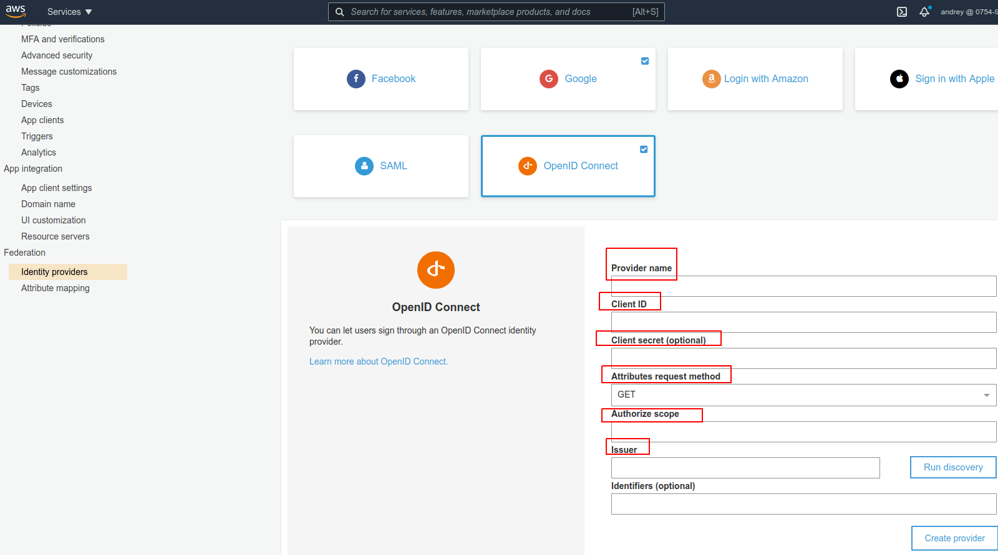
  - Provider name: “Microsoft”
  - Client ID: the one you’ve copied in step 6.a of AzureAD setup
  - Client secret: the one you’ve copied in step 9.c of AzureAD setup
  - Attributes request method: POST
  - Authorize scope: “profile email openid”
  - Issuer: take the “OpenID Connect metadata document” you’ve copied in step 7.a of AzureAD setup and remove the last characters until the URL ends with “/v2.0”.
Example: https://login.microsoftonline.com/57b5dfcc-c2a4-4cde-af50-xxxxxxxxxx/v2.0
  - Click “Run discovery” and you should see a success message. If you don’t - there’s probably a misconfiguration issue on the AzureAD side or the URL is incorrect.
  - Click “Create provider” - you should see it under “Active OIDC Providers”
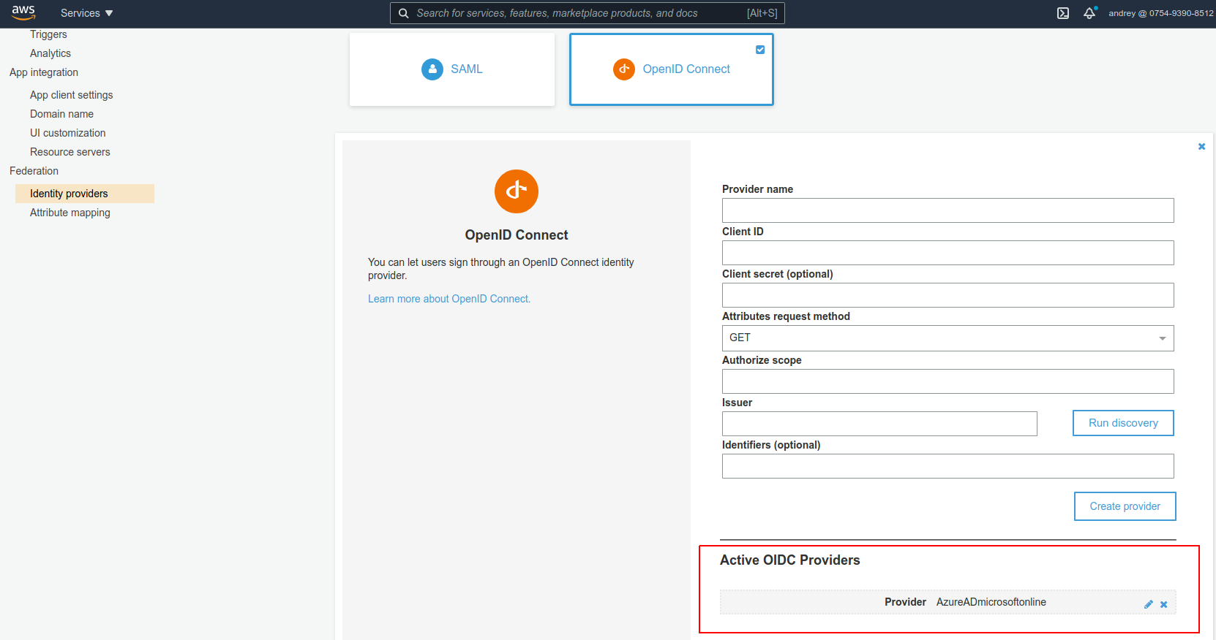
- Go to “Attribute mapping” on the left side menu and browse to “OIDC” tab
  - Add “OIDC attribute”s to get the following state:
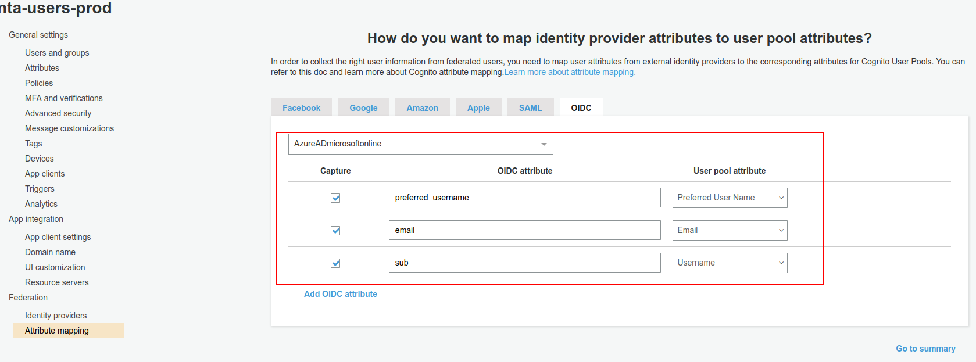
  - Save
- Go to “App client settings” in the left side menu and mark the checkbox named “MicrosoftAzureAD”
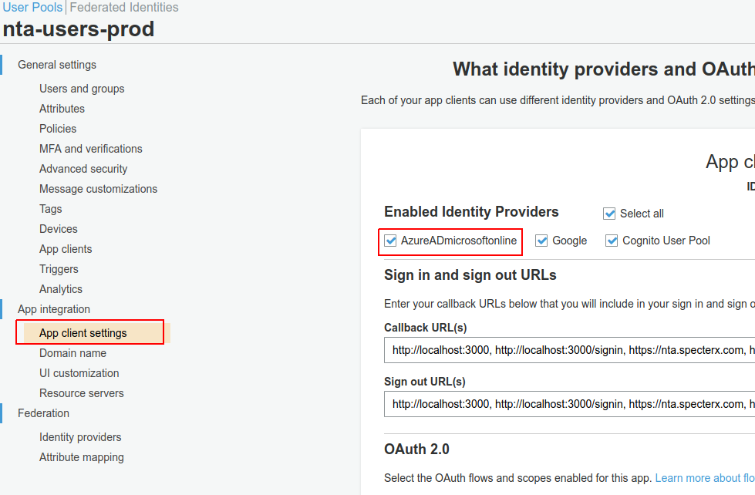
- Save changes

Go and test login with your shiny new Federated IdP:
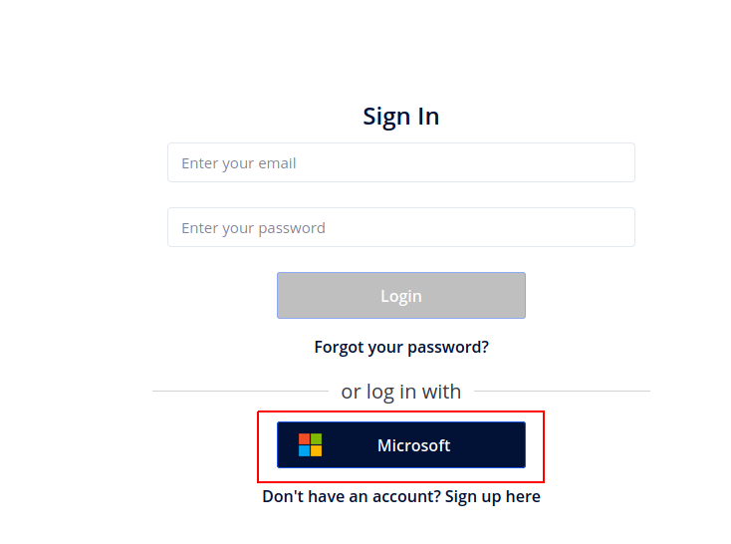
You should see an option with the name you’ve given to your OIDC provider in AWS Cognito
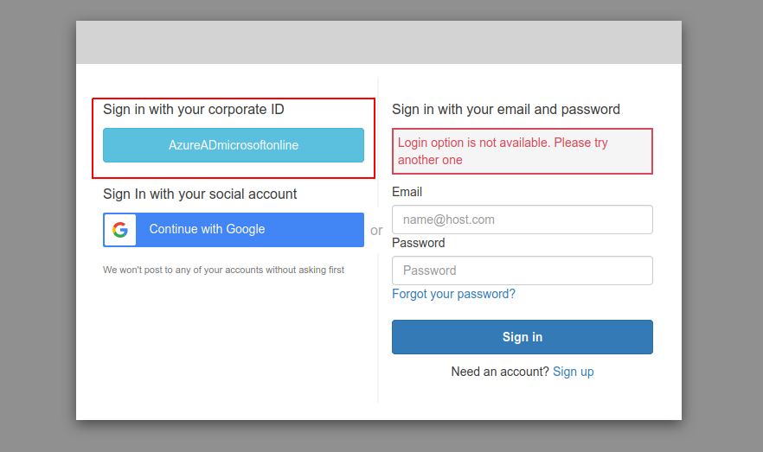

Click it, login with the Azure AD user credentials and the app should load:
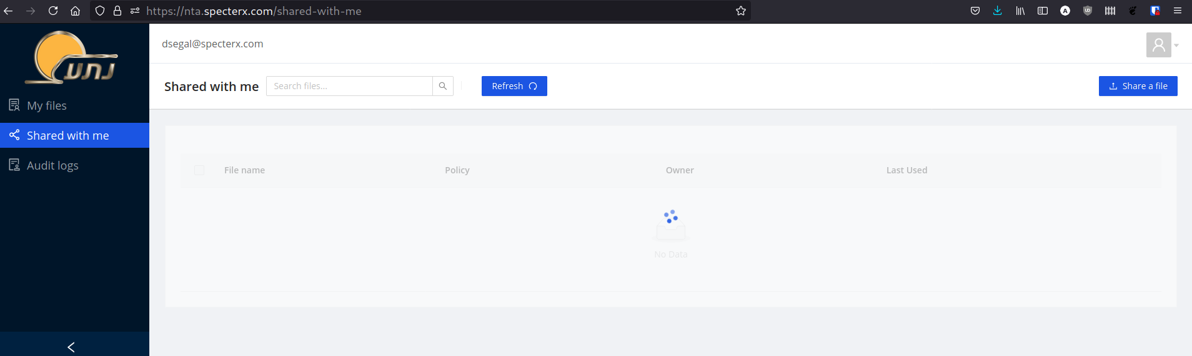

Have yourself a well deserved drink and a moment to appreciate the simpler things in life.

